Organization/Setup
defining features to prevent inconsistency later - must exist in simulation, mocap, and derived video data
most mocap datasets do not include force data, deriving would be too noisy - will only focus on angular displacements + velocities

feature list
- knee flexion angle
- knee valgus angle
- hip flexion angle
- ankle dorsiflexion angle
- knee flexion angular velocity
- knee valgus angular velocity
datasets
feature | CMU | AMASS | Human3.6M
desc | 3d marker trajectories (.c3d), full body marker sets  no force plates, joint torques, joint angles  run IK to extract joint angles  old & noisy though, not good for training | SMPL body params, joint angles, lots of motions  no GRFs, forces  !! - SMPL joints to not match opensim, need to map | video + mocap hybrid  3d joint positions + synced video  no forces/torques  secondary dataset - good for validating video pipeline
knee flexion angle | yes (IK) | yes, manual mapping | yes (IK)
knee valgus angle | yes (IK) | possibly? | yes (IK)
hip flexion angle | yes (IK) | yes, manual mapping | yes (IK)
ankle dorsiflexion angle | yes (IK) | yes, manual mapping | yes (IK)
knee flexion angular velocity | yes (IK) | yes, manual mapping + IK | yes (IK)
knee valgus angular velocity | yes (IK) | possibly? | yes (IK)
scale? | no | yes | med

verdict
no dataset used for both training & testing
OpenSim = define physics-based thresholds for injury patterns, label mocap + video data accordingly for training

training set
- sim = opensim
- mocap = AMASS (scale)
- video = Human3.6M -> MediaPipe

testing set
- mocap = CMU
- video = penn-action/UCF -> MediaPipe (may change)

Using torque
- since opensim can simulate moments, we can use this to our advantage
- torque can be used to recognize and define angle + velocity thresholds for labeling purposes
- by doing this, we learn what kinematic patterns imply high torque (and therefore injury thresholds), and train the model on only that
- model will never see torque in inputs or training data, but will instead end up learning what causes high torques

OpenSim = ‘teacher’
- extracts angles, computes velocities + torques
- labels temporal (frame) windows based on all (thresholds created)
- drops torque channel before being given as input data

Mocap + Video = ‘students’
- extracts angles, computes velocities
- uses labels (thresholds) from teacher on its frames
- given as input data

not the same type of data across domains - cross domain training still has benefits because of:
- noise distribution (opensim = less noisy, video derived = very noisy)
- label confidence (opensim = physics driven, mocap = heuristic, video derived = weak)

Dataset Creation
Model: Rajagopal2016.osim
simulate at 100Hz (downsample for ML later, probably 60Hz)

First attempt - download c3d files from CMU/AMASS, convert to trc & run IK + ID in OpenSim
- lots of issues with conversion
- when converted, formatting is extremely difficult as OpenSim is very picky about headers, spacing, etc. - would basically have to go in and manually edit

Second attempt - use existing .mot files from rajagopal example sets, starting with walking, and slightly perturb angles to get X different datasets
- this should take out the formatting issues
- once I do this, I can also hand write my own .mot files for different motions, and then run the perturbation sequence to generate data

CHANGE IN METHODOLOGY: will most likely switch from using datasets for mocap to handwritten mocap - will use video for later testing if possible

first proof-of-concept script for joint kinematics perturbation working: joint kinematics perturbation script.ipynb

to change torques, perturb:
- joint kinematics (.mot)
- GRFs (.mot)
output: torques (moments), (.sto)
couple & train!

so in summary:
stays the same | model file (Rajagopal2016.osim)  external loads xml (external_loads.xml)  ID setup file (setup_id.xml)  frame rate, frame number, sampling rate
perturbed | joint kinematics (ananyalikescheese.mot)  → modify knee adduction, hip adduction, etc.  grfs (cheesegrfs.mot)  → most likely severity scale (x1, x1.1, x1.2, x1.3) - since we are perturbing both in the same script, severity will prob control both but will be parsed in different ways
resulting after ID | inverse_dynamics_output.sto  → contains torque moments
model trained on… | X: joint kinematics (ananyalikescheese.mot)  y: torques (inverse_dynamics_output.sto)
model tested on… | joint kinematics
model will predict… | joint torques
post | if any moment/combination is above certain torque threshold, dangerous
to script:
- edit current JK perturbation script to perturb with thresholds
- create GRF perturbation script to perturb with severity levels
- create bulk ID script (OpenSim API) to get .sto files
- create & train regression model (RF or 3 layer MLP most likely)
- define torque thresholds for post

grfs_run.xml = external_loads
cant use opensim on colab - need to run locally
python bindings install: https://opensimconfluence.atlassian.net/wiki/spaces/OpenSim/pages/53085346/Scripting+in+Python#Manual-installation-(OpenSim-4.3-or-later)
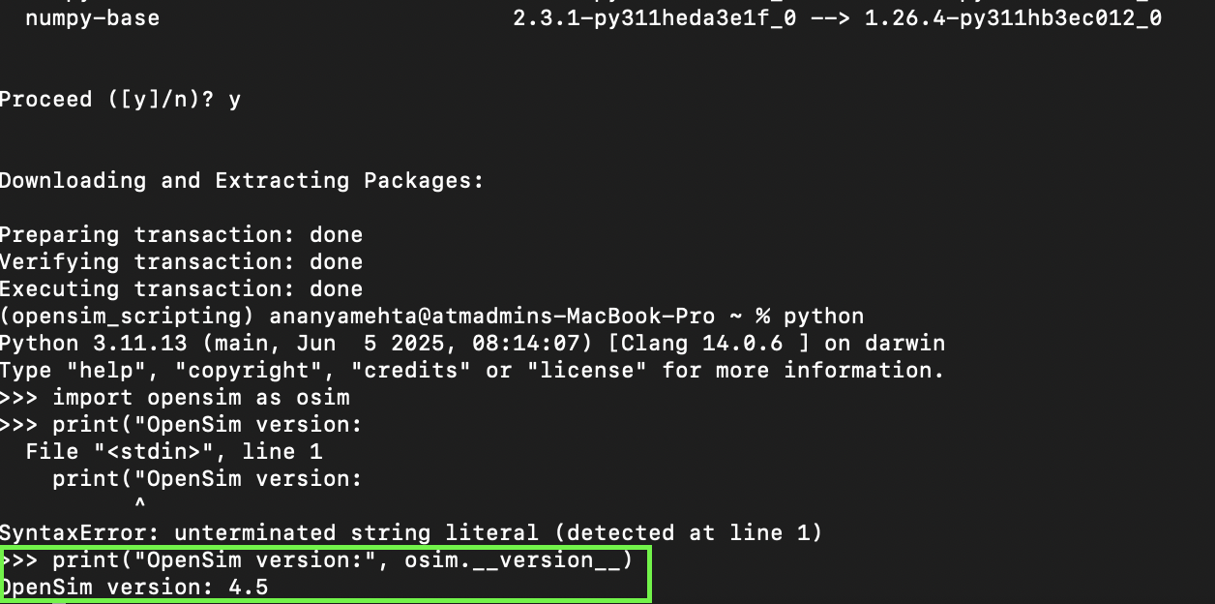
can read version numbers, which means python bindings are working!

Dataset Generation v1 (proof of concept-ish?)
import numpy as np
import pandas as pd
import os
import random
import opensim as osim

BASE_DIR = os.getcwd()

MODEL_PATH = os.path.join(BASE_DIR, "constant/Rajagopal2016.osim")
SETUP_PATH = os.path.join(BASE_DIR, "constant/setup_id.xml")
EXTERNAL_LOADS = os.path.join(BASE_DIR, "constant/external_loads.xml")

BASE_JK = os.path.join(BASE_DIR, "base_inputs/running_JK_base.mot")
BASE_GRF = os.path.join(BASE_DIR, "base_inputs/running_GRF_base.mot")

OUT_JK = os.path.join(BASE_DIR, "generated/jk")
OUT_GRF = os.path.join(BASE_DIR, "generated/grf")
OUT_STO = os.path.join(BASE_DIR, "generated/sto")

os.makedirs(OUT_JK, exist_ok=True)
os.makedirs(OUT_GRF, exist_ok=True)
os.makedirs(OUT_STO, exist_ok=True)

# ---- Safety Checks i am losing it ----
for path in [MODEL_PATH, SETUP_PATH, EXTERNAL_LOADS, BASE_JK, BASE_GRF]:
if not os.path.exists(path):
raise FileNotFoundError(f"Missing required file :((: {path}")

N_PER_SEVERITY = 5

SEVERITY_CONFIG = {
0: {"valgus": (0,1), "grf": (1.00,1.02)},
1: {"valgus": (2,3), "grf": (1.05,1.10)},
2: {"valgus": (4,5), "grf": (1.15,1.20)},
3: {"valgus": (6,8), "grf": (1.25,1.35)}
}

def load_mot(filepath):
with open(filepath, 'r') as f:
lines = f.readlines()

header_end = None
for i, line in enumerate(lines):
if "endheader" in line.lower():
header_end = i
break

if header_end is None:
raise ValueError(f"'endheader' not found in {filepath}")

header = lines[:header_end+1]
data = pd.read_csv(filepath, sep="\t", skiprows=header_end+1)
return header, data

def save_mot(filepath, header, df):
with open(filepath, 'w') as f:
f.writelines(header)
df.to_csv(f, sep="\t", index=False)

def perturb_jk(df, severity):
df_new = df.copy()

valgus_min, valgus_max = SEVERITY_CONFIG[severity]["valgus"]
valgus_deg = random.uniform(valgus_min, valgus_max)
valgus_rad = np.deg2rad(valgus_deg)

if "knee_adduction_r" in df_new.columns:
window = np.exp(-((np.linspace(-2, 2, len(df_new)))**2))
df_new["knee_adduction_r"] += valgus_rad * window
else:
print("Warning: knee_adduction_r not found in JK file.")

return df_new

def perturb_grf(df, severity):
df_new = df.copy()

scale_min, scale_max = SEVERITY_CONFIG[severity]["grf"]
scale = random.uniform(scale_min, scale_max)

if "ground_force_vy" in df_new.columns:
df_new["ground_force_vy"] *= scale
else:
print("Warning: ground_force_vy not found in GRF file.")

return df_new

def run_id(jk_path, grf_path, sto_out):
tool = osim.InverseDynamicsTool(SETUP_PATH)
tool.setModelFileName(MODEL_PATH)
tool.setCoordinatesFileName(jk_path)

# Load and override GRF data file
external_loads = osim.ExternalLoads(EXTERNAL_LOADS, True)
external_loads.setDataFileName(grf_path)

tool.setExternalLoads(external_loads)
tool.setOutputGenForceFileName(sto_out)

tool.run()

# ---- Load Base Data ----
jk_header, jk_base = load_mot(BASE_JK)
grf_header, grf_base = load_mot(BASE_GRF)

# ---- Dataset Generation ----
for severity in SEVERITY_CONFIG.keys():
for i in range(N_PER_SEVERITY):

sample_id = f"run_S{severity}_{i:03d}"

jk_out = os.path.join(OUT_JK, f"{sample_id}_JK.mot")
grf_out = os.path.join(OUT_GRF, f"{sample_id}_GRF.mot")
sto_out = os.path.join(OUT_STO, f"{sample_id}.sto")

jk_new = perturb_jk(jk_base, severity)
grf_new = perturb_grf(grf_base, severity)

save_mot(jk_out, jk_header, jk_new)
save_mot(grf_out, grf_header, grf_new)

run_id(jk_out, grf_out, sto_out)

print(f"Completed: {sample_id}")

print("Dataset generation complete.")

slight problem - external_loads.xml has hardcoded file path - will continue using the same base GRF file even when perturbations are created - this needs to be dynamically updated in the script as well
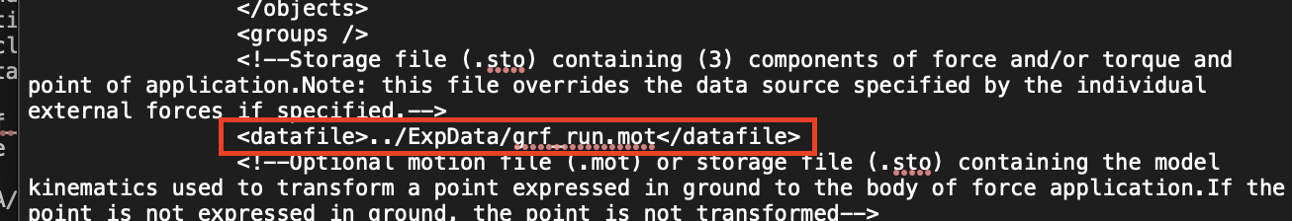
fix:
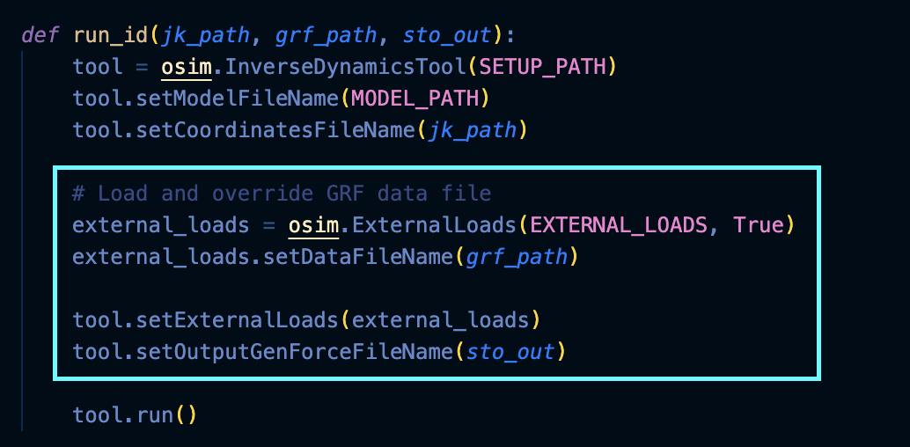

Modeling consideration (more edits before dataset creation)
right now, only 2 degrees of freedom - scalar valgus magnitude, GRF scaling
for diversity, want to incorporate some of these:

IMPLEMENTATION IDEAS (+ pseudocode)

1. randomizing valgus timing & width
right now:

window = np.exp(-((np.linspace(-2,2,len(df)))**2))

this always peaks in the middle and has a fixed width
instead, can pick a random peak index inside stance, random width, and center there for each trial

n = len(df)
t = np.linspace(0, 1, n)

center = random.uniform(0.2, 0.8) # peak location (20–80% stance)
width = random.uniform(0.05, 0.15) # Gaussian width

window = np.exp(-((t - center)**2) / (2 * width**2))

2. multi joint coupling
right now we are essentially assuming that valgus collapse is isolated (but it isn’t irl)
want to couple to hip_adduction, pelvis_list, knee_flexion (?)

hip_scale = random.uniform(0.3, 0.6)
pelvis_scale = random.uniform(0.2, 0.4)

df["knee_adduction_r"] += valgus_rad * window
df["hip_adduction_r"] += hip_scale * valgus_rad * window
df["pelvis_list"] += pelvis_scale * valgus_rad * window

3. modifying GRF shape (not just scaling amplitude)
right now we have:

df["ground_force_vy"] *= scale

which only scales amplitude. for more diversity, we can shift the peak timing ± 2%

shift = random.uniform(-0.02, 0.02) # 2% stance shift
shifted_grf = interpolate_shift(df["ground_force_vy"], shift)

and since there are usually 2 peaks in running GRF, can modify first to second peak ratio with some scaling variable:

first_peak_scale = random.uniform(0.9, 1.1)
second_peak_scale = random.uniform(0.9, 1.1)

4. adding smooth noise
the data we are synthetically creating is way too squeaky clean

noise_amp = random.uniform(0.005, 0.02) # 0.5–2%
smooth_noise = gaussian_filter(np.random.randn(n), sigma=20)
df[column] += noise_amp * smooth_noise

this noise will be added to knee adduction, GRFs, hip moment, etc., since real mocap is not perfect and CNN (even if 1D) could overfit to perfect gaussians

(maybes**)
**5. small temporal stretch or compression
optional because it requires resampling afterwards, so it may crash and burn
if it doesn't, it can add lots more diversity, and can almost emulate different trials a bit better (not really different people, but close)

warp_factor = random.uniform(0.95, 1.05)

new_time = np.linspace(0, 1, int(n * warp_factor))
warped_signal = interpolate(original_signal, new_time)

**6. vary perturbation shape so its not always gaussian
optional because we don't know if this is going to be a problem with 1D CNNs, but if ML wants to memorize gaussian bumps it will help with that
instead of always using gaussian, can randomly choose between that, half-sine, skewed gaussian, etc.)

shape_type = random.choice(["gaussian", "sine"])

if shape_type == "sine":
window = np.sin(np.pi * local_region)

ADDED TO ORIGINAL SCRIPT:
New perturb_jk():
def perturb_jk(df, severity):
df_new = df.copy()
n = len(df_new)
t = np.linspace(0, 1, n)

# ---- Valgus Magnitude ----
valgus_min, valgus_max = SEVERITY_CONFIG[severity]["valgus"]
valgus_deg = random.uniform(valgus_min, valgus_max)
valgus_rad = np.deg2rad(valgus_deg)

# ---- Random Timing + Width ----
center = random.uniform(0.2, 0.8)
width = random.uniform(0.05, 0.15)
window = np.exp(-((t - center) ** 2) / (2 * width ** 2))

# ---- Multi-joint Coupling ----
hip_scale = random.uniform(0.3, 0.6)
pelvis_scale = random.uniform(0.2, 0.4)

if "knee_adduction_r" in df_new.columns:
df_new["knee_adduction_r"] += valgus_rad * window

if "hip_adduction_r" in df_new.columns:
df_new["hip_adduction_r"] += hip_scale * valgus_rad * window

if "pelvis_list" in df_new.columns:
df_new["pelvis_list"] += pelvis_scale * valgus_rad * window

# ---- Add Smooth Low-Amplitude Noise ----
noise_amp = random.uniform(0.002, 0.01) # radians
smooth_noise = np.convolve(
np.random.randn(n), np.ones(25)/25, mode="same"
)
df_new += noise_amp * smooth_noise[:, None]

return df_new

New perturb_grf():
def perturb_grf(df, severity):
df_new = df.copy()
n = len(df_new)
t = np.linspace(0, 1, n)

scale_min, scale_max = SEVERITY_CONFIG[severity]["grf"]
global_scale = random.uniform(scale_min, scale_max)

# ---- Base Vertical Scaling ----
if "ground_force_vy" in df_new.columns:
df_new["ground_force_vy"] *= global_scale

# ---- Peak Shape Modulation ----
peak_shift = random.uniform(-0.05, 0.05)
peak_width = random.uniform(0.05, 0.15)

peak_window = np.exp(
-((t - (0.5 + peak_shift)) ** 2) / (2 * peak_width ** 2)
)

peak_mod = random.uniform(0.9, 1.1)
df_new["ground_force_vy"] *= (1 + (peak_mod - 1) * peak_window)

# ---- Small AP Variation (if exists) ----
if "ground_force_vx" in df_new.columns:
ap_scale = random.uniform(0.95, 1.05)
df_new["ground_force_vx"] *= ap_scale

# ---- Add Smooth Noise ----
noise_amp = random.uniform(0.005, 0.02)
smooth_noise = np.convolve(
np.random.randn(n), np.ones(25)/25, mode="same"
)

for col in df_new.columns:
if "ground_force" in col:
df_new[col] += noise_amp * smooth_noise

return df_new

run with 300 N per severity = 1200 total

GRF_RUN errors…
test run:
—
[info] Running tool id_run...
[info] ExternalLoads 'grf_run' was renamed and is being reset to 'externalloads'.
[error] IO.OpenInputFile(const string&,openmode mode): failed to open ../ExpData/grf_run.mot.
[error] Failed to read ExternalLoads data file '../ExpData/grf_run.mot'.
Traceback (most recent call last):
File "/Users/ananyamehta/opensim_project/generate_dataset.py", line 102, in <module>
run_id(jk_out, sto_out)
File "/Users/ananyamehta/opensim_project/generate_dataset.py", line 82, in run_id
tool.run()
File "/Applications/OpenSim 4.5/sdk/Python/opensim/tools.py", line 2422, in run
return _tools.InverseDynamicsTool_run(self)
^^^^^^^^^^^^^^^^^^^^^^^^^^^^^^^^^^^^
RuntimeError: std::exception in 'bool OpenSim::InverseDynamicsTool::run()': std::exception
—
this means that opensim is still reading the original XML instead of perturbed grf file
change to run_id():

def run_id(jk_path, grf_path, sto_out):

tool = osim.InverseDynamicsTool(SETUP_PATH)

tool.setModelFileName(MODEL_PATH)
tool.setCoordinatesFileName(jk_path)
tool.setOutputGenForceFileName(sto_out)

# ensure tool uses external loads file
tool.setExternalLoadsFileName(EXTERNAL_LOADS)

# modify the loaded ExternalLoads object
external_loads = tool.updExternalLoads()
external_loads.setDataFileName(grf_path)

# debug
# print("Using GRF file:", external_loads.getDataFileName())

tool.run()
also, change hardcoded reference in setup_id.xml from grf_run to external_loads

still the same error…override is still not taking effect

debug #1: is there another reference to grf_run in setup_id.xml?
no, no other references, so that cannot be the issue
some other internal reload behavior is happening

debug #2: completely override XML filepath for each run
new run_id():

def run_id(jk_path, grf_path, sto_out):

# Create a temporary external loads XML
temp_external = os.path.join(BASE_DIR, "temp_external_loads.xml")

with open(EXTERNAL_LOADS, "r") as f:
xml_text = f.read()

# Replace datafile path
import re
xml_text = re.sub(
r"<datafile>.*?</datafile>",
f"<datafile>{grf_path}</datafile>",
xml_text
)

with open(temp_external, "w") as f:
f.write(xml_text)

tool = osim.InverseDynamicsTool(SETUP_PATH)
tool.setModelFileName(MODEL_PATH)
tool.setCoordinatesFileName(jk_path)
tool.setExternalLoadsFileName(temp_external)
tool.setOutputGenForceFileName(sto_out)

tool.run()

# cleanup
os.remove(temp_external)

actual error: vscode was saving in a different folder, opensim_project still had the old script
script now generates data!

^^ figured this out after looking more closely at tracebacks and seeing only 2 arguments instead of 3, which was from my older version

minor change - bypass default opensim folder setup (wants to create results_run for sto files - we want it to go into the sto directory created, which will be easier when doing ML later) - did not do this before for debugging purposes:

tool.setResultsDir(OUT_STO)
tool.setOutputGenForceFileName(os.path.basename(sto_out))

Validation
short validation script to make sure .sto files are good:

checks first 5 files for:
- able to load with OpenSim
- basic dimensions check
- time vector check (strictly increasing)
- data matrix - no NaN values

import os
import numpy as np
import opensim as osim

STO_DIR = "generated/sto"

def validate_sto_file(filepath):
print(f"\nChecking: {os.path.basename(filepath)}")

# Try loading with OpenSim
try:
table = osim.TimeSeriesTable(filepath)
except Exception as e:
print("Cannot load file:", e)
return False

# Basic dimensions
n_rows = table.getNumRows()
n_cols = table.getNumColumns()

print("Rows:", n_rows)
print("Columns:", n_cols)

if n_rows == 0:
print("No data rows")
return False

# Time vector check
time = np.array(table.getIndependentColumn())

if not np.all(np.diff(time) > 0):
print("AYO Time not strictly increasing")
return False

# Data matrix
data = table.getMatrix().to_numpy()

if np.isnan(data).any():
print("NaNs detected")
return False

max_val = np.max(np.abs(data))
print("Max abs value:", max_val)

if max_val > 1e6:
print("SuspISHUSly large values")

print("File looks valid")
return True

def main():
files = [f for f in os.listdir(STO_DIR) if f.endswith(".sto")]

if not files:
print("No STO files found.")
return

print("Found", len(files), "STO files")

all_valid = True

for f in files[:5]: # check first 5 for quick validation
valid = validate_sto_file(os.path.join(STO_DIR, f))
if not valid:
all_valid = False

if all_valid:
print("\n All checked files look good!")
else:
print("\n Some files failed validation :((")

if __name__ == "__main__":
main()

results: looks good! (ran with 20 per severity, so 80 .sto files total)
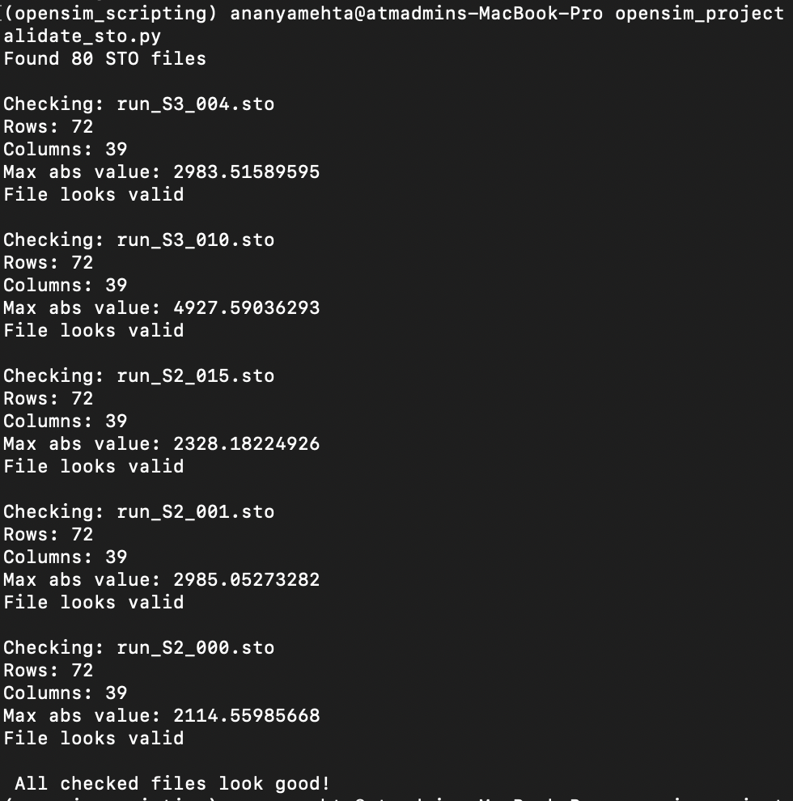

before running 1D CNN, I want to run a validation script to check whether the CNN will work or not. basically includes

Likely some of the .sto files have slightly different shapes - running quick diagnostic to check. If so, we would pad/flatten them to fit (especially if its only 1 outlier).

result:
(72, 39) : 75
(73, 39) : 5

last frame is generally redundant - meaning we could trim down to get a uniform data size.

fixed issue, but PCA looks bad:
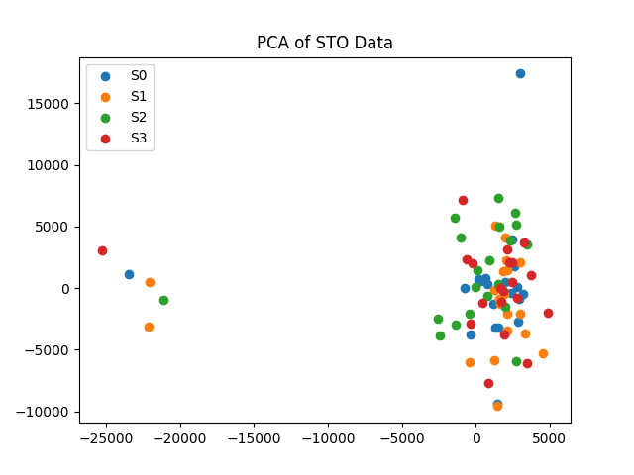
also, the severity scaling is not going up uniformly like it should be, so this graph makes sense (why its overlapping).

S0: Mean Abs Torque = 119.34
S1: Mean Abs Torque = 117.17
S2: Mean Abs Torque = 116.56
S3: Mean Abs Torque = 120.66
updated severity scale, still no improvement
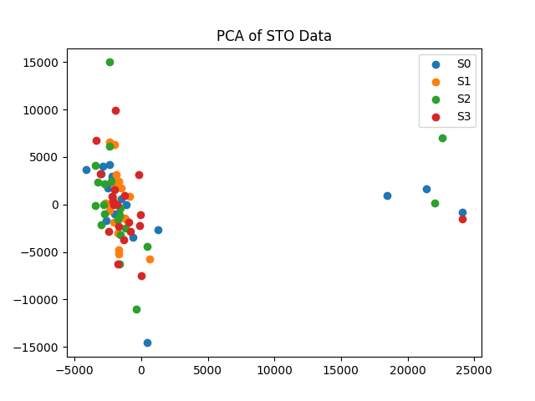
S0: Mean Abs Torque = 118.45
S1: Mean Abs Torque = 113.24
S2: Mean Abs Torque = 120.08
S3: Mean Abs Torque = 119.56

so increasing severity itself doesn’t help, architecture itself needs to change:
- make GRF scaling stronger and more systematic
- make vertical GRF scaling severity-dominant
- increase AP scaling slightly with severity
- reduce random modulation that cancels effects
- make valgus perturbation slightly stronger at high severity
- make noise smaller relative to deterministic scaling

still performing badly:
Samples: 80
Features per sample: 2808
--- Severity Scaling Check ---
S0: Mean Abs Torque = 95.51
S1: Mean Abs Torque = 95.93
S2: Mean Abs Torque = 98.75
S3: Mean Abs Torque = 102.51
--- PCA Separability Check ---
--- Logistic Regression Baseline ---
Random Split Accuracy: 37.50%
--- Cross-Severity Generalization ---
Train S0–S2, Test S3 Accuracy: 0.00%

train on larger dataset? right now only using 80 samples. will run 200 per severity (800 total) and see results.

Samples: 800
Features per sample: 2808
--- Severity Scaling Check ---
S0: Mean Abs Torque = 95.51
S1: Mean Abs Torque = 96.33
S2: Mean Abs Torque = 98.76
S3: Mean Abs Torque = 102.39
--- PCA Separability Check ---
--- Logistic Regression Baseline ---
/Users/ananyamehta/anaconda3/envs/opensim_scripting/lib/python3.11/site-packages/sklearn/linear_model/_logistic.py:406: ConvergenceWarning: lbfgs failed to converge after 5000 iteration(s) (status=1):
STOP: TOTAL NO. OF ITERATIONS REACHED LIMIT
Increase the number of iterations to improve the convergence (max_iter=5000).
You might also want to scale the data as shown in:
https://scikit-learn.org/stable/modules/preprocessing.html
Please also refer to the documentation for alternative solver options:
https://scikit-learn.org/stable/modules/linear_model.html#logistic-regression
n_iter_i = _check_optimize_result(
Random Split Accuracy: 51.88%
--- Cross-Severity Generalization ---
/Users/ananyamehta/anaconda3/envs/opensim_scripting/lib/python3.11/site-packages/sklearn/linear_model/_logistic.py:406: ConvergenceWarning: lbfgs failed to converge after 5000 iteration(s) (status=1):
STOP: TOTAL NO. OF ITERATIONS REACHED LIMIT
Increase the number of iterations to improve the convergence (max_iter=5000).
You might also want to scale the data as shown in:
https://scikit-learn.org/stable/modules/preprocessing.html
Please also refer to the documentation for alternative solver options:
https://scikit-learn.org/stable/modules/linear_model.html#logistic-regression
n_iter_i = _check_optimize_result(
Train S0–S2, Test S3 Accuracy: 0.00%

accuracy jumped to 52% - more than double of random, means there is separable structure
convergence warnings because too many features for logistic regression, mainly serving as a pretest to make sure structure exists so expected
NEED TO NORMALIZE INPUTS (this is probably the main reason)
also save sto files as csvs, and convert them to .npy so ML doesnt need opensim (much faster to run all processes)
after generating this data ^^^, ran validation again:
Raw shape: (800, 72, 39)
Samples: 800
Timesteps: 72
Features per timestep: 39
Flattened features: 2808
--- Severity Scaling Check ---
S0: Mean Abs Torque = 95.51
S1: Mean Abs Torque = 96.18
S2: Mean Abs Torque = 98.82
S3: Mean Abs Torque = 101.60
--- Logistic Regression Baseline ---
Random Split Accuracy: 60.00%
--- Binary Low vs High Severity Diagnostic ---
Binary Accuracy: 80.00%
--- Interpretation ---
Moderate signal detected. CNN likely beneficial.
Binary separation is stronger than fine-grained severity separation.

severity increase is constant (still a small margin though)
60% = 2.4x random (25%), so clearly a pattern - logistic regression is probably struggling here mainly due to temporal dependencies, which will be much better in a CNN, so good sign it is able to get this high!
binary separation is working very well considering its LogReg, but multiclass classification (multiple severity scales) is struggling more - possibly due to marginal increase (so lots of data will be overlapping).

Now, all of these problems are things that will likely perform much better with CNN - at least a 30-35% increase, maybe more

onwards!

Pre-ML Success Criteria Editing
- Simulation Data Accuracy: The OpenSim-generated simulation data (joint angles, angular velocities, and estimated torques) must demonstrate internal physical consistency, with less than 5% variance between forward and inverse dynamics calculations for identical poses.
  - This can remain the same - is actually more important now that we are generating synthetic data
- Real Mocap Alignment: The same joint-angle features extracted from real motion-capture datasets (e.g., AMASS or CMU) must align with simulated features within a mean angular deviation of ±7° for equivalent movements.
  - no longer using datasets, so this does not apply.
- ML Model Classification Performance: The trained ML model must correctly classify “risky” vs. “safe” movement segments with at least 85% accuracy on test data not used in training.
  - this has been edited to introduce more detail in the model’s performance: instead of just predicting safe vs risky, for any given torque moment being tested, it should be able to determine severity level accurately.
- Video to Kinematics Consistency: For videos processed via MediaPipe or similar tools, the inferred joint angles must remain within ±10° of corresponding angles from MoCap data for the same movement.
  - Deferred to after real-world testing for now - since MediaPipe is not reliable and cannot derive angles accurately enough most likely, it will be a proof of concept and not part of the actual success criteria
- Generalization Across Sources: The model trained on simulated + real MoCap data must maintain ≥ 75% accuracy when classifying movement risk from video-derived joint data (a cross-domain test).
  - This becomes testing on unseen perturbation patterns - training and testing on different perturbation levels.
- Computational Efficiency: The full pipeline - from video input to risk prediction - must process each frame in under 0.001 seconds (1 ms)
  - this is still okay, but changing it to 0.001 second since inferencing locally should not take very long per sample, should be under a millisecond

New Success Criteria:

- Simulation Data Accuracy: For identical kinematic inputs and ground reaction forces, inverse dynamics outputs must vary by no more than 5% in 90% of repeated runs.
- ML Model Severity Classification Performance: The trained ML model must accurately classify perturbation severity levels (S0 to S3) for unseen synthetic samples by achieving 85% or higher classification accuracy on a held-out test dataset.
- Cross-Perturbation Generalization: The model must demonstrate generalization over unseen perturbation levels by training on a subset of severity levels and testing on higher or unseen levels, and maintaining 70% or higher classification accuracy on a held-out dataset.
- Computational Efficiency: The full inference pipeline, from input data to final severity prediction, must process each sample (frame) in under 0.001 (1ms) second on local hardware.

ML
ML Model Choice: 1D CNN, using pytorch
- handles time series better than other simple regression models
- stable
- easier to train
- works well with 1000-2000 samples

Also, CNNs due to their architecture are good at finding deeper relationships in neighboring frames - which again makes it very good for very nonlinear relations in time series.

Model Architecture/Logic planning
Conv1D(39 → 64 filters, kernel=5)
ReLU
Conv1D(64 → 128 filters, kernel=5)
ReLU
GlobalAveragePooling
FullyConnected(128 → 4)

version 1 script (important parts)
Loading data for CNN + standardization logic:
X = np.load(os.path.join(DATA_DIR, "X.npy")) # (samples, 72, 39)
y = np.load(os.path.join(DATA_DIR, "y.npy"))

# transpose for CNN (samples, channels, time)
X = np.transpose(X, (0, 2, 1)) #(N, 39, 72)

# scale
X_flat = X.reshape(X.shape[0], -1)
scaler = StandardScaler()
X_scaled = scaler.fit_transform(X_flat)
X_scaled = X_scaled.reshape(X.shape)

CNN model:
class CNN1D(nn.Module):
def __init__(self):
super(CNN1D, self).__init__()

self.conv1 = nn.Conv1d(in_channels=39, out_channels=64, kernel_size=5)
self.conv2 = nn.Conv1d(64, 128, kernel_size=5)

self.relu = nn.ReLU()
self.pool = nn.AdaptiveAvgPool1d(1)

self.dropout = nn.Dropout(0.3)
self.fc = nn.Linear(128, 4)

def forward(self, x):

x = self.relu(self.conv1(x))
x = self.relu(self.conv2(x))

x = self.pool(x) # (batch, 128, 1)
x = x.squeeze(-1) # (batch, 128)

x = self.dropout(x)
x = self.fc(x)

return x

model = CNN1D().to(DEVICE)

criterion = nn.CrossEntropyLoss()
optimizer = optim.Adam(model.parameters(), lr=LEARNING_RATE)

Training loop;
train_losses = []
val_accuracies = []

print("\nStarting training...\n")

for epoch in range(EPOCHS):

model.train()
permutation = torch.randperm(X_train.size(0))

epoch_loss = 0

for i in range(0, X_train.size(0), BATCH_SIZE):

indices = permutation[i:i+BATCH_SIZE]
batch_x = X_train[indices]
batch_y = y_train[indices]

optimizer.zero_grad()

outputs = model(batch_x)
loss = criterion(outputs, batch_y)

loss.backward()
optimizer.step()

epoch_loss += loss.item()

epoch_loss /= (X_train.size(0) // BATCH_SIZE)
train_losses.append(epoch_loss)

# Validation
model.eval()
with torch.no_grad():
val_outputs = model(X_val)
preds = torch.argmax(val_outputs, dim=1)
acc = accuracy_score(
y_val.cpu().numpy(),
preds.cpu().numpy()
)

val_accuracies.append(acc)

print(f"Epoch {epoch+1:02d}/{EPOCHS} | Loss: {epoch_loss:.4f} | Val Acc: {acc*100:.2f}%")

Final eval
model.eval()
with torch.no_grad():
val_outputs = model(X_val)
preds = torch.argmax(val_outputs, dim=1)

final_acc = accuracy_score(
y_val.cpu().numpy(),
preds.cpu().numpy()
)

First run results:
Loading dataset...
Train samples: 640
Validation samples: 160
Starting training...
Epoch 01/40 | Loss: 1.2291 | Val Acc: 25.00%
Epoch 02/40 | Loss: 1.1187 | Val Acc: 50.00%
Epoch 03/40 | Loss: 1.0189 | Val Acc: 51.88%
Epoch 04/40 | Loss: 0.8309 | Val Acc: 65.00%
Epoch 05/40 | Loss: 0.6465 | Val Acc: 80.00%
Epoch 06/40 | Loss: 0.5265 | Val Acc: 85.00%
Epoch 07/40 | Loss: 0.4295 | Val Acc: 80.62%
Epoch 08/40 | Loss: 0.3593 | Val Acc: 87.50%
Epoch 09/40 | Loss: 0.3000 | Val Acc: 90.62%
Epoch 10/40 | Loss: 0.2655 | Val Acc: 93.75%
Epoch 11/40 | Loss: 0.2064 | Val Acc: 92.50%
Epoch 12/40 | Loss: 0.1898 | Val Acc: 91.88%
Epoch 13/40 | Loss: 0.1873 | Val Acc: 96.25%
Epoch 14/40 | Loss: 0.1430 | Val Acc: 96.88%
Epoch 15/40 | Loss: 0.1181 | Val Acc: 95.62%
Epoch 16/40 | Loss: 0.1052 | Val Acc: 97.50%
Epoch 17/40 | Loss: 0.0948 | Val Acc: 94.38%
Epoch 18/40 | Loss: 0.0852 | Val Acc: 95.62%
Epoch 19/40 | Loss: 0.0778 | Val Acc: 95.62%
Epoch 20/40 | Loss: 0.0738 | Val Acc: 96.88%
Epoch 21/40 | Loss: 0.0682 | Val Acc: 96.88%
Epoch 22/40 | Loss: 0.0680 | Val Acc: 96.88%
Epoch 23/40 | Loss: 0.0599 | Val Acc: 95.00%
Epoch 24/40 | Loss: 0.0657 | Val Acc: 98.12%
Epoch 25/40 | Loss: 0.0602 | Val Acc: 97.50%
Epoch 26/40 | Loss: 0.0574 | Val Acc: 98.75%
Epoch 27/40 | Loss: 0.0567 | Val Acc: 92.50%
Epoch 28/40 | Loss: 0.0477 | Val Acc: 95.62%
Epoch 29/40 | Loss: 0.0456 | Val Acc: 97.50%
Epoch 30/40 | Loss: 0.0491 | Val Acc: 93.12%
Epoch 31/40 | Loss: 0.0540 | Val Acc: 93.12%
Epoch 32/40 | Loss: 0.0341 | Val Acc: 93.75%
Epoch 33/40 | Loss: 0.0370 | Val Acc: 95.62%
Epoch 34/40 | Loss: 0.0284 | Val Acc: 93.12%
Epoch 35/40 | Loss: 0.0464 | Val Acc: 96.88%
Epoch 36/40 | Loss: 0.0583 | Val Acc: 96.25%
Epoch 37/40 | Loss: 0.0601 | Val Acc: 96.25%
Epoch 38/40 | Loss: 0.0511 | Val Acc: 93.75%
Epoch 39/40 | Loss: 0.0334 | Val Acc: 93.75%
Epoch 40/40 | Loss: 0.0250 | Val Acc: 97.50%
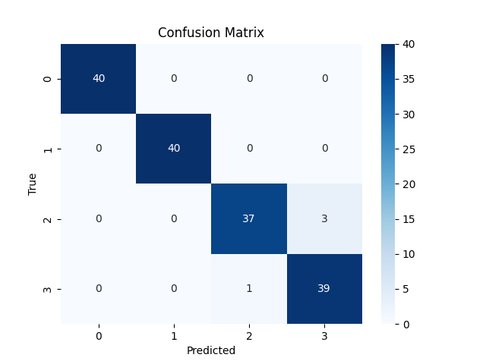
Final Validation Accuracy: 97.50%
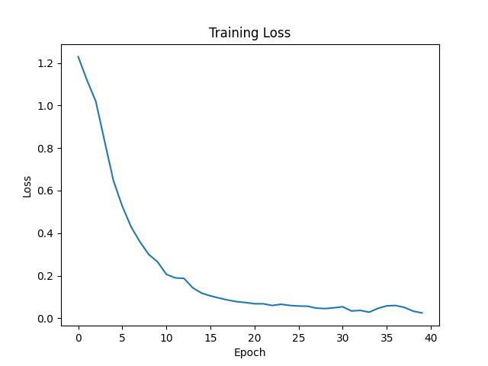
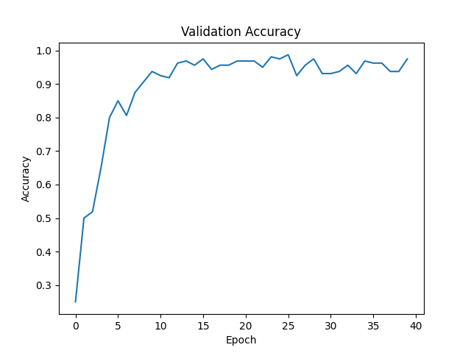
First thought - this is way too good to be true??
biggest source of data leak would be the validation and training samples being too similar (makes sense, since they're from the same dataset) - but no catastrophic data leakage

training curve looks like genuine learning, no wild divergence, and loss looks normal as well

Validation of the results
very minor leakage could be happening since im technically splitting after doing full scalar, but this wouldn't cause major leakage. easy fix, easy to rerun and check:

Loading dataset...
Train samples: 640
Validation samples: 160
Starting training...
Epoch 01/40 | Loss: 1.1735 | Val Acc: 50.00%
Epoch 02/40 | Loss: 1.0731 | Val Acc: 50.00%
Epoch 03/40 | Loss: 0.9802 | Val Acc: 54.37%
Epoch 04/40 | Loss: 0.8389 | Val Acc: 65.62%
Epoch 05/40 | Loss: 0.6607 | Val Acc: 66.88%
Epoch 06/40 | Loss: 0.5398 | Val Acc: 90.00%
Epoch 07/40 | Loss: 0.4523 | Val Acc: 84.38%
Epoch 08/40 | Loss: 0.3889 | Val Acc: 88.12%
Epoch 09/40 | Loss: 0.3264 | Val Acc: 93.12%
Epoch 10/40 | Loss: 0.2595 | Val Acc: 90.62%
Epoch 11/40 | Loss: 0.2160 | Val Acc: 96.25%
Epoch 12/40 | Loss: 0.1882 | Val Acc: 96.25%
Epoch 13/40 | Loss: 0.1627 | Val Acc: 91.25%
Epoch 14/40 | Loss: 0.1387 | Val Acc: 95.00%
Epoch 15/40 | Loss: 0.1045 | Val Acc: 96.25%
Epoch 16/40 | Loss: 0.1018 | Val Acc: 96.88%
Epoch 17/40 | Loss: 0.0988 | Val Acc: 92.50%
Epoch 18/40 | Loss: 0.0889 | Val Acc: 96.25%
Epoch 19/40 | Loss: 0.0760 | Val Acc: 94.38%
Epoch 20/40 | Loss: 0.0828 | Val Acc: 96.88%
Epoch 21/40 | Loss: 0.0822 | Val Acc: 97.50%
Epoch 22/40 | Loss: 0.0547 | Val Acc: 97.50%
Epoch 23/40 | Loss: 0.0502 | Val Acc: 97.50%
Epoch 24/40 | Loss: 0.0500 | Val Acc: 98.75%
Epoch 25/40 | Loss: 0.0600 | Val Acc: 96.25%
Epoch 26/40 | Loss: 0.0524 | Val Acc: 96.88%
Epoch 27/40 | Loss: 0.0476 | Val Acc: 94.38%
Epoch 28/40 | Loss: 0.0333 | Val Acc: 98.12%
Epoch 29/40 | Loss: 0.0369 | Val Acc: 98.12%
Epoch 30/40 | Loss: 0.0312 | Val Acc: 97.50%
Epoch 31/40 | Loss: 0.0298 | Val Acc: 91.88%
Epoch 32/40 | Loss: 0.0245 | Val Acc: 93.12%
Epoch 33/40 | Loss: 0.0389 | Val Acc: 98.12%
Epoch 34/40 | Loss: 0.0301 | Val Acc: 94.38%
Epoch 35/40 | Loss: 0.0268 | Val Acc: 93.12%
Epoch 36/40 | Loss: 0.0222 | Val Acc: 94.38%
Epoch 37/40 | Loss: 0.0190 | Val Acc: 93.75%
Epoch 38/40 | Loss: 0.0225 | Val Acc: 90.62%
Epoch 39/40 | Loss: 0.0348 | Val Acc: 97.50%
Epoch 40/40 | Loss: 0.0322 | Val Acc: 96.25%
Final Validation Accuracy: 96.25%

everything still looks good - wasn’t a huge issue, but good to fix it anyways

there are 2 other tests I want to run that I feel like would verify the results slight;y :
- randomizing y_train (shuffling labels so to speak)
  - if there was any data leakage, the accuracy would stay high. by doing this, we are essentially destroying some patterns, so accuracy should drop quite low
- reduce dataset size to 400 to see if accuracy drops SIGNIFICANTLY (expect a drop obviously, but shouldn't be super severe - 5-10%)

for label shuffling:
# -----------------------------
# LABEL SHUFFLE TEST (TEMPORARY)
# -----------------------------
# Uncomment this block to test leakage

# y_train = y_train[torch.randperm(len(y_train))]
# print("Running label shuffle test...")

at the beginning of training loop
Starting training...
Running label shuffle test...
Epoch 01/40 | Loss: 1.3968 | Val Acc: 25.00%
Epoch 02/40 | Loss: 1.3926 | Val Acc: 24.38%
Epoch 03/40 | Loss: 1.3864 | Val Acc: 41.88%
Epoch 04/40 | Loss: 1.3861 | Val Acc: 50.00%
Epoch 05/40 | Loss: 1.3841 | Val Acc: 33.12%
Epoch 06/40 | Loss: 1.3838 | Val Acc: 47.50%
Epoch 07/40 | Loss: 1.3811 | Val Acc: 45.00%
Epoch 08/40 | Loss: 1.3806 | Val Acc: 43.75%
Epoch 09/40 | Loss: 1.3774 | Val Acc: 39.38%
Epoch 10/40 | Loss: 1.3716 | Val Acc: 38.75%
Epoch 11/40 | Loss: 1.3754 | Val Acc: 41.88%
Epoch 12/40 | Loss: 1.3728 | Val Acc: 37.50%
Epoch 13/40 | Loss: 1.3675 | Val Acc: 40.62%
Epoch 14/40 | Loss: 1.3632 | Val Acc: 45.00%
Epoch 15/40 | Loss: 1.3657 | Val Acc: 46.88%
Epoch 16/40 | Loss: 1.3477 | Val Acc: 43.75%
Epoch 17/40 | Loss: 1.3522 | Val Acc: 49.38%
Epoch 18/40 | Loss: 1.3494 | Val Acc: 48.12%
Epoch 19/40 | Loss: 1.3430 | Val Acc: 28.12%
Epoch 20/40 | Loss: 1.3365 | Val Acc: 41.25%
Epoch 21/40 | Loss: 1.3248 | Val Acc: 44.38%
Epoch 22/40 | Loss: 1.3227 | Val Acc: 49.38%
Epoch 23/40 | Loss: 1.3235 | Val Acc: 48.75%
Epoch 24/40 | Loss: 1.3082 | Val Acc: 36.88%
Epoch 25/40 | Loss: 1.3167 | Val Acc: 41.25%
Epoch 26/40 | Loss: 1.2875 | Val Acc: 45.62%
Epoch 27/40 | Loss: 1.2738 | Val Acc: 35.00%
Epoch 28/40 | Loss: 1.2856 | Val Acc: 42.50%
Epoch 29/40 | Loss: 1.2855 | Val Acc: 50.00%
Epoch 30/40 | Loss: 1.2749 | Val Acc: 38.75%
Epoch 31/40 | Loss: 1.2459 | Val Acc: 45.00%
Epoch 32/40 | Loss: 1.2431 | Val Acc: 39.38%
Epoch 33/40 | Loss: 1.2420 | Val Acc: 41.25%
Epoch 34/40 | Loss: 1.2213 | Val Acc: 41.25%
Epoch 35/40 | Loss: 1.2013 | Val Acc: 50.00%
Epoch 36/40 | Loss: 1.2061 | Val Acc: 41.25%
Epoch 37/40 | Loss: 1.2152 | Val Acc: 40.00%
Epoch 38/40 | Loss: 1.2178 | Val Acc: 28.12%
Epoch 39/40 | Loss: 1.1892 | Val Acc: 46.88%
Epoch 40/40 | Loss: 1.1953 | Val Acc: 44.38%
Final Validation Accuracy: 44.38%
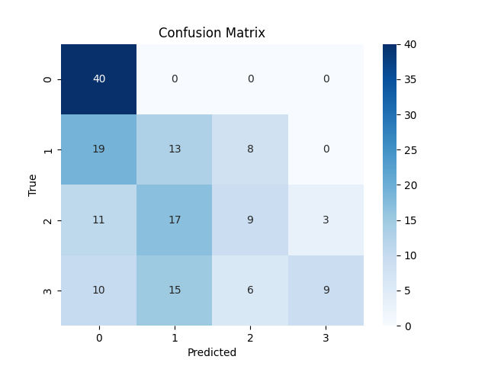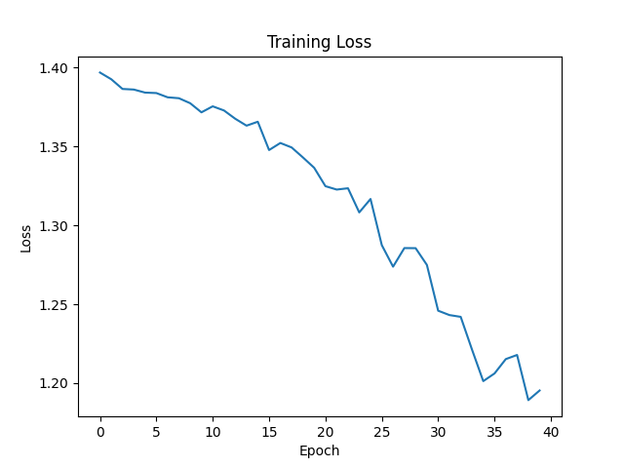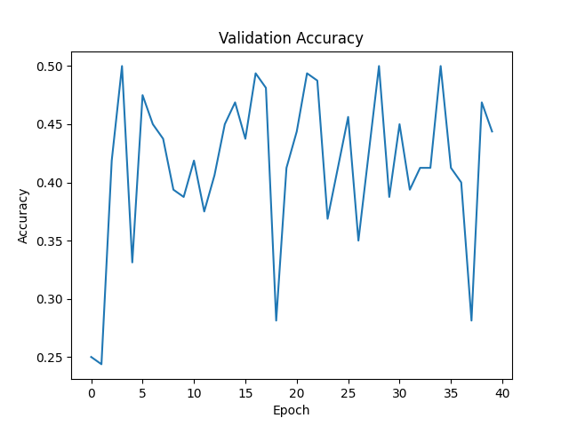
this is a good result, means that there is no leakage - the model is trying to genuinely learn corrupted data, and (obviously) is not able to do so very well.

dataset reduction:

def subset_dataset(X, y, samples_per_class=100):
X_new = []
y_new = []

for severity in np.unique(y):
idx = np.where(y == severity)[0][:samples_per_class]
X_new.append(X[idx])
y_new.append(y[idx])

X_new = np.concatenate(X_new, axis=0)
y_new = np.concatenate(y_new, axis=0)

return X_new, y_new

# -----------------------------
# Reduce dataset size
# -----------------------------
# Uncomment to use 400 samples (100 per class)

X, y = subset_dataset(X, y, samples_per_class=100)
print(f"Using reduced dataset: {len(X)} samples")

#----

Loading dataset...
Using reduced dataset: 400 samples
Train samples: 320
Validation samples: 80
Starting training...
Epoch 01/40 | Loss: 1.2786 | Val Acc: 25.00%
Epoch 02/40 | Loss: 1.1772 | Val Acc: 25.00%
Epoch 03/40 | Loss: 1.1275 | Val Acc: 50.00%
Epoch 04/40 | Loss: 1.0988 | Val Acc: 50.00%
Epoch 05/40 | Loss: 1.0490 | Val Acc: 50.00%
Epoch 06/40 | Loss: 0.9675 | Val Acc: 51.25%
Epoch 07/40 | Loss: 0.8892 | Val Acc: 65.00%
Epoch 08/40 | Loss: 0.7858 | Val Acc: 82.50%
Epoch 09/40 | Loss: 0.6945 | Val Acc: 67.50%
Epoch 10/40 | Loss: 0.6088 | Val Acc: 83.75%
Epoch 11/40 | Loss: 0.5618 | Val Acc: 78.75%
Epoch 12/40 | Loss: 0.5190 | Val Acc: 73.75%
Epoch 13/40 | Loss: 0.4710 | Val Acc: 80.00%
Epoch 14/40 | Loss: 0.4240 | Val Acc: 81.25%
Epoch 15/40 | Loss: 0.3926 | Val Acc: 85.00%
Epoch 16/40 | Loss: 0.3629 | Val Acc: 81.25%
Epoch 17/40 | Loss: 0.3297 | Val Acc: 82.50%
Epoch 18/40 | Loss: 0.2795 | Val Acc: 88.75%
Epoch 19/40 | Loss: 0.2954 | Val Acc: 92.50%
Epoch 20/40 | Loss: 0.2825 | Val Acc: 93.75%
Epoch 21/40 | Loss: 0.2408 | Val Acc: 87.50%
Epoch 22/40 | Loss: 0.1988 | Val Acc: 90.00%
Epoch 23/40 | Loss: 0.1807 | Val Acc: 96.25%
Epoch 24/40 | Loss: 0.1924 | Val Acc: 93.75%
Epoch 25/40 | Loss: 0.1604 | Val Acc: 95.00%
Epoch 26/40 | Loss: 0.1565 | Val Acc: 96.25%
Epoch 27/40 | Loss: 0.1271 | Val Acc: 96.25%
Epoch 28/40 | Loss: 0.1150 | Val Acc: 92.50%
Epoch 29/40 | Loss: 0.1068 | Val Acc: 95.00%
Epoch 30/40 | Loss: 0.1065 | Val Acc: 96.25%
Epoch 31/40 | Loss: 0.1095 | Val Acc: 93.75%
Epoch 32/40 | Loss: 0.1015 | Val Acc: 90.00%
Epoch 33/40 | Loss: 0.1017 | Val Acc: 88.75%
Epoch 34/40 | Loss: 0.1083 | Val Acc: 86.25%
Epoch 35/40 | Loss: 0.0985 | Val Acc: 86.25%
Epoch 36/40 | Loss: 0.0799 | Val Acc: 95.00%
Epoch 37/40 | Loss: 0.0539 | Val Acc: 97.50%
Epoch 38/40 | Loss: 0.0637 | Val Acc: 98.75%
Epoch 39/40 | Loss: 0.0526 | Val Acc: 93.75%
Epoch 40/40 | Loss: 0.0384 | Val Acc: 92.50%
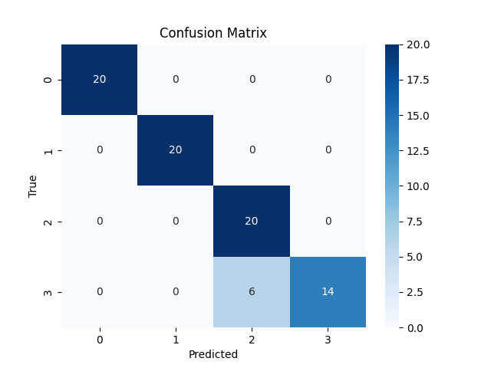
Final Validation Accuracy: 92.50%
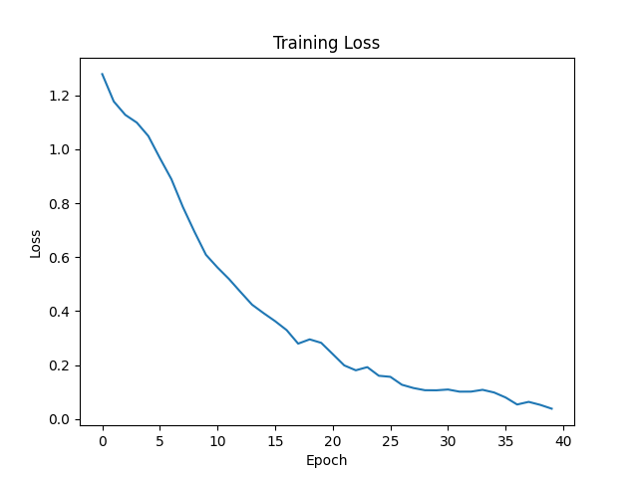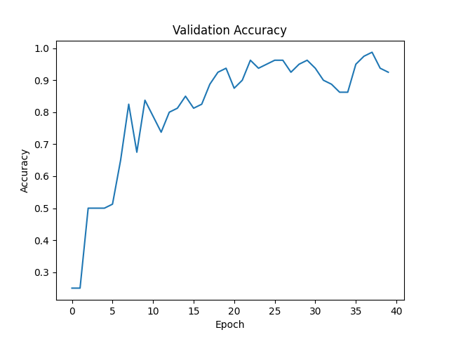

This also works as expected!
performance stayed high even with half the data - but not an insane jump, meaning that the signal is strong and the CNN is recognizing real patterns (not just overfitting to large large amounts of data)
the 5% drop shows that the model is behaving as expected, and that the model expectedly benefits a bit from more data.

This means the original 97.5% accuracy is valid (most likely, there isn’t any other indication)
🎉🎉🎉🎉🎉🎉🎉🎉🎉🎉🎉🎉🎉🎉🎉🎉🎉🎉🎉

Success Criteria Testing
Will make some temporary modifications to the script/make another script for testing success criteria

sim data accuracy - will be in dataset generation script, will do last
pseudo:
if RUN_SIMULATION_TEST:
fixed_input = select_one_sample()
repeat_outputs = []

for i in range(N):
output = run_inverse_dynamics(fixed_input)
repeat_outputs.append(output)

compute_percent_variation()

print("Simulation stability:", percent_within_5)
exit()

ML Hold-Out
pseudo:
requires a true test set, so must replace
train / validation split
with
train, val, test
after training,
if RUN_STANDARD_TEST:
test_accuracy = evaluate(model, test_loader)
print("Held-out test accuracy:", test_accuracy)
no architecture change required

cross severity generalization
needs to temporarily override split logic, so should be run separately from everything else
using new model inside loop, not reusing trained one:
pseudo:
if RUN_GENERALIZATION_TEST:

for severity in [S0, S1, S2, S3]:

train_data = all samples where label != severity
test_data = all samples where label == severity

initialize new model
train model
acc = evaluate on test_data

store acc

print(all_generalization_results)

computational efficiency
does not alter training
pseudo:
if RUN_EFFICIENCY_TEST:

select 100 test samples

start timer

for each sample:
model(sample)

stop timer

avg_time = total_time / 100

print("Avg inference time:", avg_time)

Testing

ML Holdout & Computational efficiency
test/sample response:
--- Held-Out Test Performance ---
Test Accuracy: 95.00%
PASS
--- Computational Efficiency ---
Average inference time per sample: 0.000287 seconds
PASS
good, means these success criteria are valid! now to run 50 times

Generalization → Noise Robustness
Flaw in the logic - if i train in S0 - S2, and then ask to predict an S3, it wont be able to unless I do a regression based model

idk how this didnt cross my mind earlier

A standard classifier will not be able to classify a label it has never seen during training

New criteria: Noise Robustness
“When zero-mean Gaussian noise with standard deviation equal to 5% of the feature standard deviation is added to the held-out test inputs, the trained model must maintain at least 80% classification accuracy.”

if RUN_NOISE_ROBUSTNESS_TEST:

print("\n--- Noise Robustness Test (5% Gaussian Noise) ---")

model.eval()

# Compute noise level relative to test data
test_std = X_test.std().item()
noise_sigma = 0.05 * test_std # 5% noise

# Generate Gaussian noise
noise = torch.randn_like(X_test) * noise_sigma
X_test_noisy = X_test + noise

with torch.no_grad():
noisy_preds = torch.argmax(model(X_test_noisy), dim=1)
noisy_acc = accuracy_score(
y_test.cpu().numpy(),
noisy_preds.cpu().numpy()
)

print(f"Noisy Test Accuracy (5% noise): {noisy_acc*100:.2f}%")
print("PASS" if noisy_acc >= 0.80 else "FAIL >:(")

works, running x50

Simulation Data Accuracy (dataset generation)
making a new script to bypass some of the logic
OpenSim inverse dynamics is very deterministic and completely physics based, so realistically there should be 0 variation
SUMMARY
MeanVariation,0.000000
StdVariation,0.000000
PassRatio,1.00
FINAL PASS
which there is! 100% pass rate

Some other considerations - because this model is outputting severity levels, it can (and most likely is) learning things beyond torque. Even though danger is defined by me as torque thresholds, it can learn to find different things that give that same information without needing GRFs, ID, etc.
OR its exploiting patterns i unknowingly create - either or.

JK Only
Now, we take the exact same logic and run it on JK only. The other part of this project was seeing whether the model would be able to predict based on joint kinematics only

Right now, inverse dynamics requires GRFs, joint kinematics, etc., meaning they need force plates and other technology to be done in a real world scenario. If this model was able to accurately predict severity with JK data only, those angles could be derived from any video and be given to the model (theoretically).

So…. I edited the success criteria for Noise Robustness and Severity Classification Accuracy to include both JK + GRF and JK only, so we can see how they compare.

test - Severity Classification Accuracy: 96.6% mean accuracy, 92.5-100% range - compared to 97.05% mean accuracy with both JK and GRFs

works about the same! will now add robustness, toggles, confusion matrices, etc. to the script and run testing for it

If this model is able to predict torque this accurately, logically one of the three must be true:
- torque is very strongly encoded in kinematics
- there is a surrogate feature in joint kinematics that strongly correlates with torque
  - this would be a future area of study possibly
- the model is learning unintentional patterns in the synthetic data created and exploiting them → this is totally possible as well, and is honestly probably part of the results. I would be very surprised if my data was completely biomechanically accurate (even though I tried to make it so)

